**Evidence File**

**Evidence #1:** In the paragraph below eq (48) in page 7 of Version 1 (first online on May 20, 2022):

“

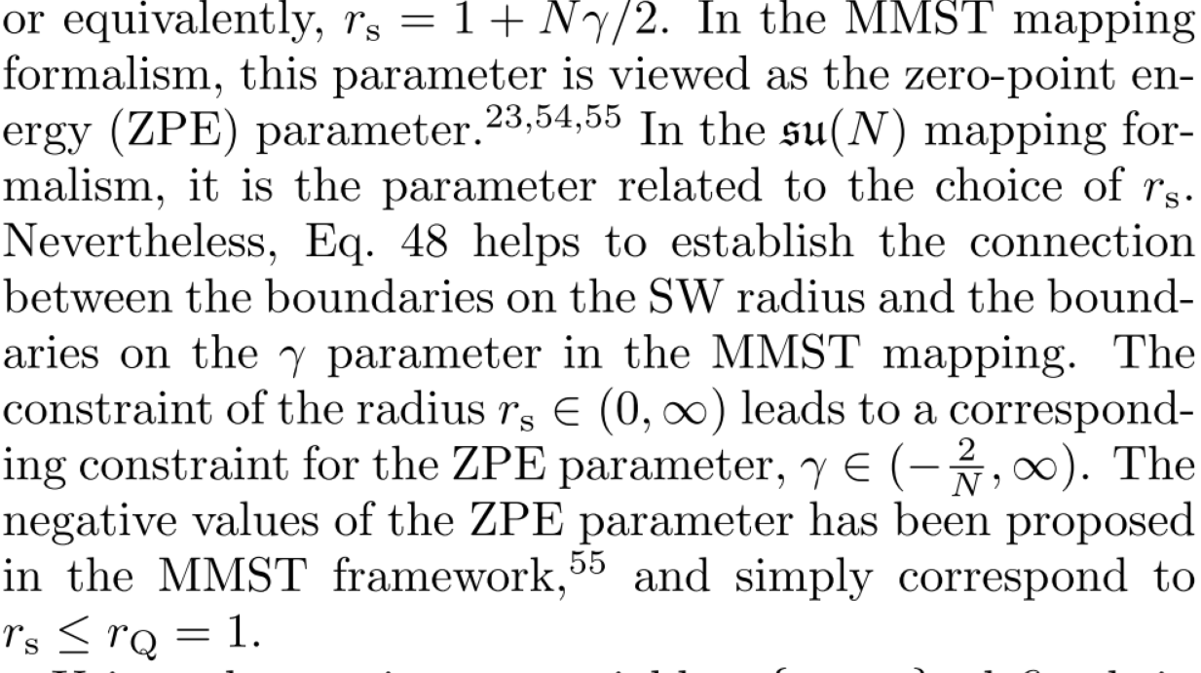

”

the paragraph below eq (51) in page 8 of Version 2 (first online on May 27, 2022):

“

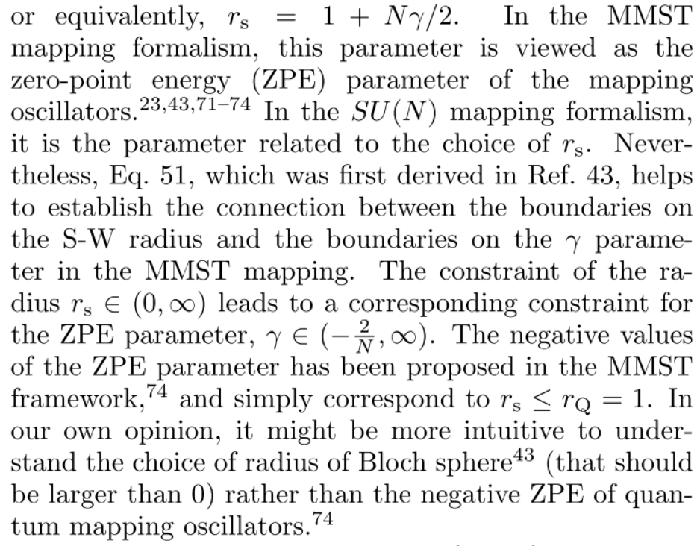

”

and the paragraph below eq (D6) in page 23 of Version 3 (accepted on July, 29, 2022):

“

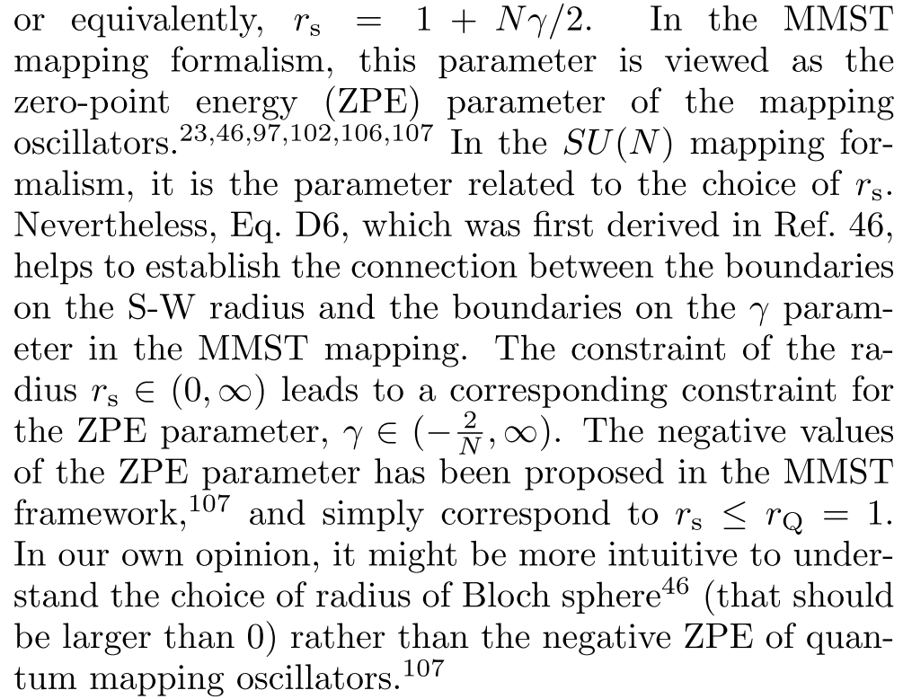

”

the corresponding statements were absolutely plagiarism from what we had mentioned above in our previous work *J. Phys. Chem. Lett.* 12, 2496–2501 (2021). The only citation was that the negative zero-point energy parameter had been proposed by us, however totally plagiarized the idea of the continuous region of . It had been first clarified in *J. Phys. Chem. Lett.* 12, 2496–2501 (2021) [Note their definition of  is two times as ours]:

“

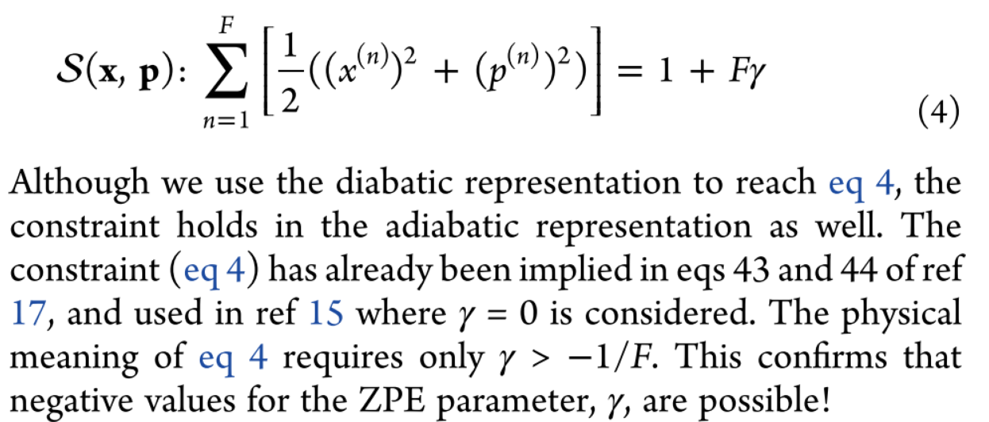

”

“

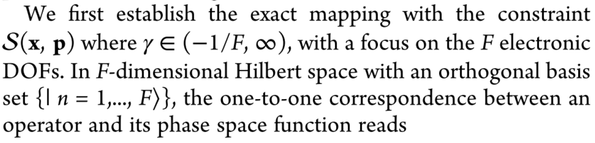

”

We also highlighted this statement and pointed out that spin mapping method with P, Q, W versions of Stratonovich phase space are only three special cases of constraint coordinate-momentum phase space used in CMM in *J. Phys. Chem. A* 125, 31, 6845–6863 (2021):

“

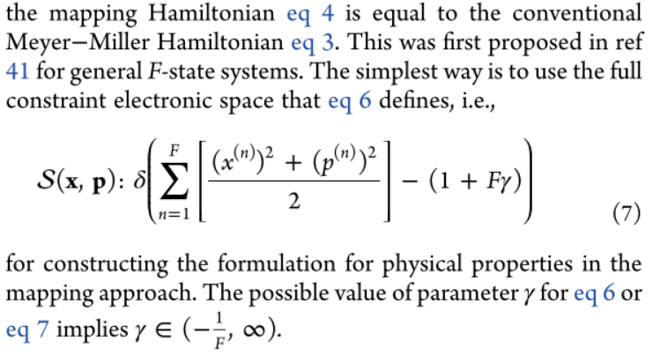

”

“

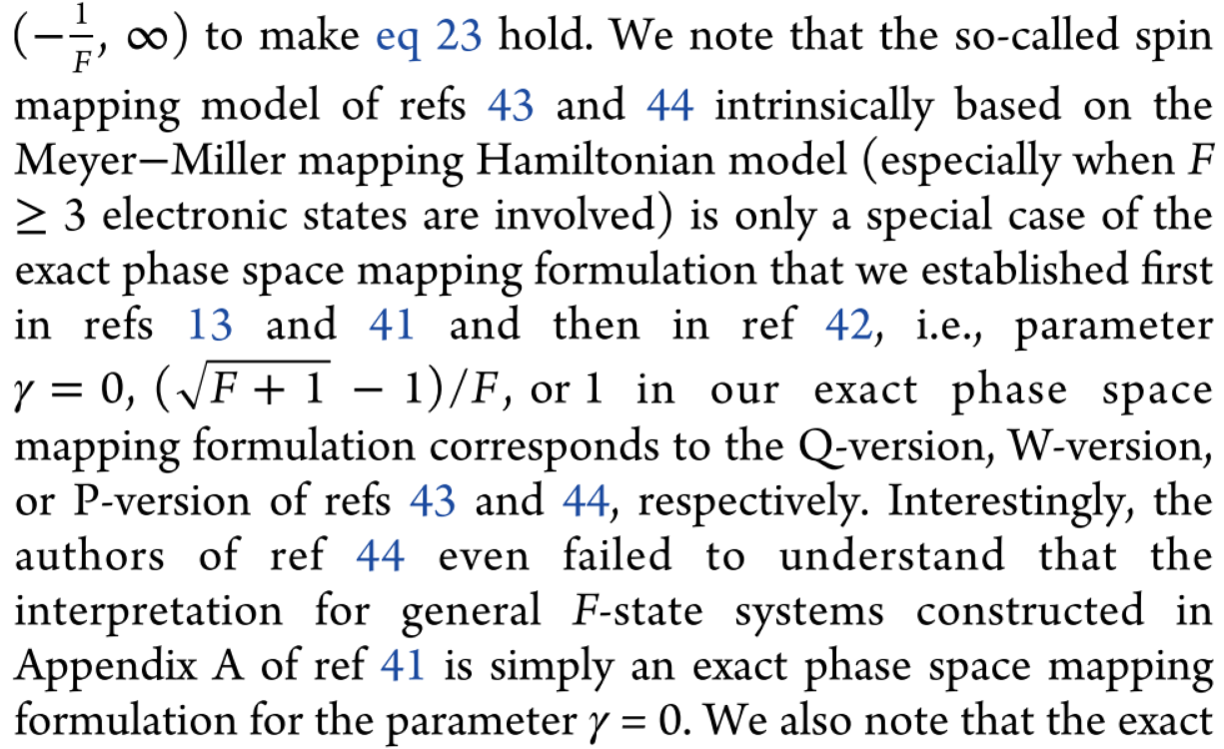

”

and *Acc. Chem. Res.* 54, 23, 4215–4228 (2021):

“

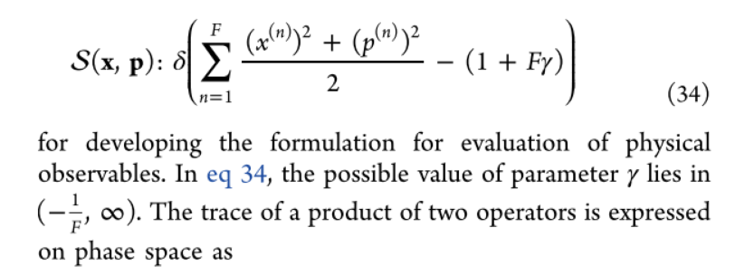

”

“

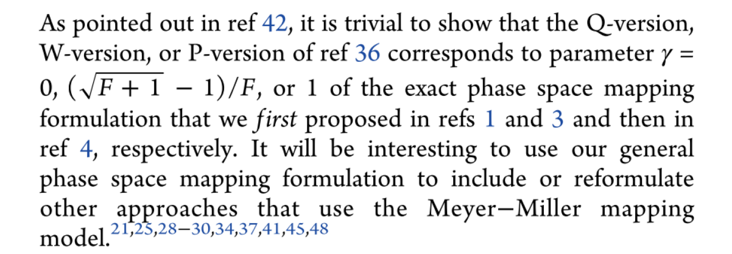

”

It should also be noticed that Huo and his coworkers never thought of the idea of continuous range of parameter  before our works. For example, in the note, Ref. 64 of Version 2(not appeared in Version 1), they mentioned that they made an incorrect statement of Stratonovich mapping kernel in their previous work [Ref. 35, *J. Chem. Phys.* 154, 184106 (2021)] for :

“

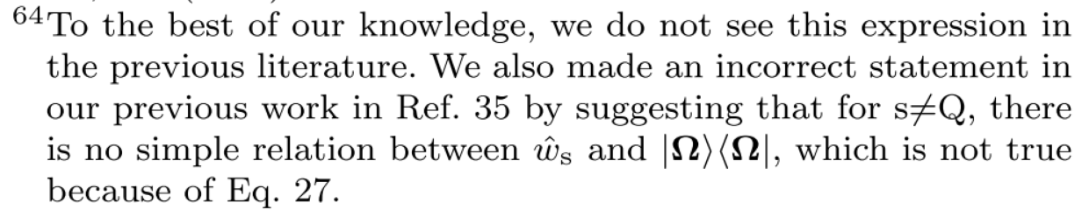

”

which still exists in the note, Ref. 65 of Version 3:

“

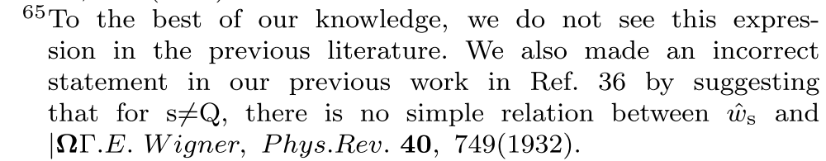

”

This note intentionally misleads its readers *as if Huo and his coworkers had already known* that the parameter lies into a continuous range, and only the point Q is special. However, this article [Ref. 35] in fact only mentioned the mapping kernel of the P, Q, or W Version of the spin mapping method proposed by Richardson *et al.*:

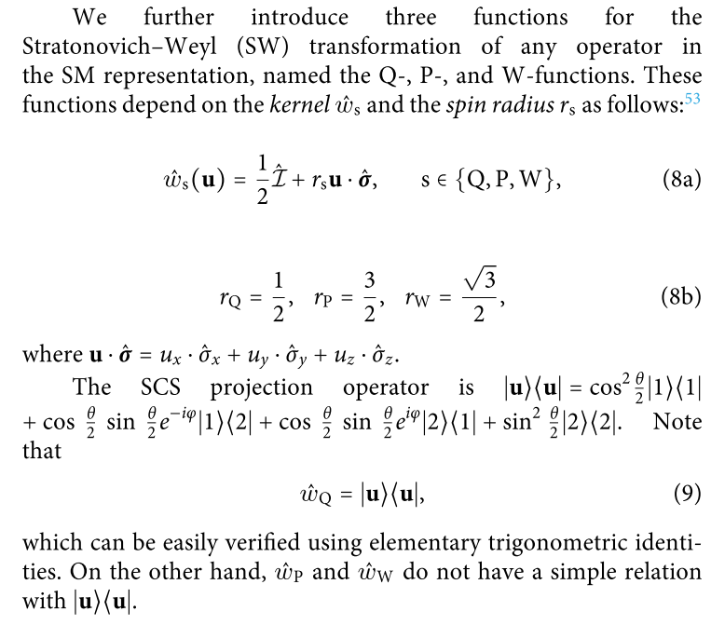

In addition, they only discussed two-state systems in this article, while we had proposed the form for the general *F*-state systems with the continuous parameter range in *J. Phys. Chem. Lett.* 12, 2496–2501 (2021) (published online on March 5, 2021) and pointed out that P, Q, W versions of the Stratonovich phase space (used in the spin mapping method) are only three special cases of “the exact phase space mapping formulation” (used in CMM) in *J. Phys. Chem. A* 125, 31, 6845–6863 (2021) (published online on August 2, 2021) and *Acc. Chem. Res.* 54, 23, 4215–4228 (2021) (published online on November 10, 2021).

**Evidence #2:** In the last paragraph of page 7 of Version 1 (first online on May 20, 2022):

“

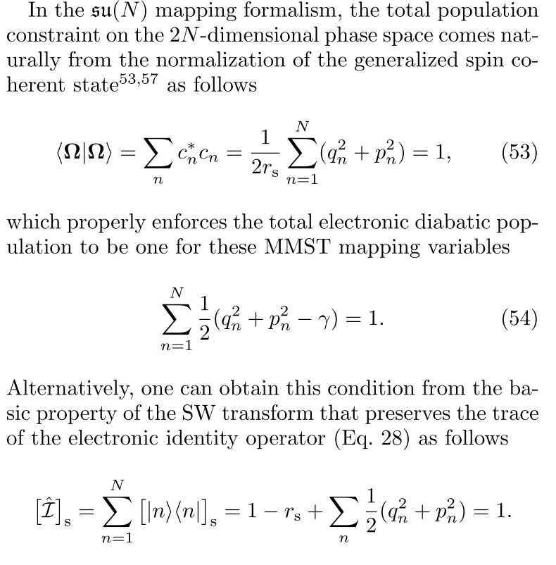

”

as well as the lower left part of page 9 of Version 2 (first online on May 27, 2022):

“

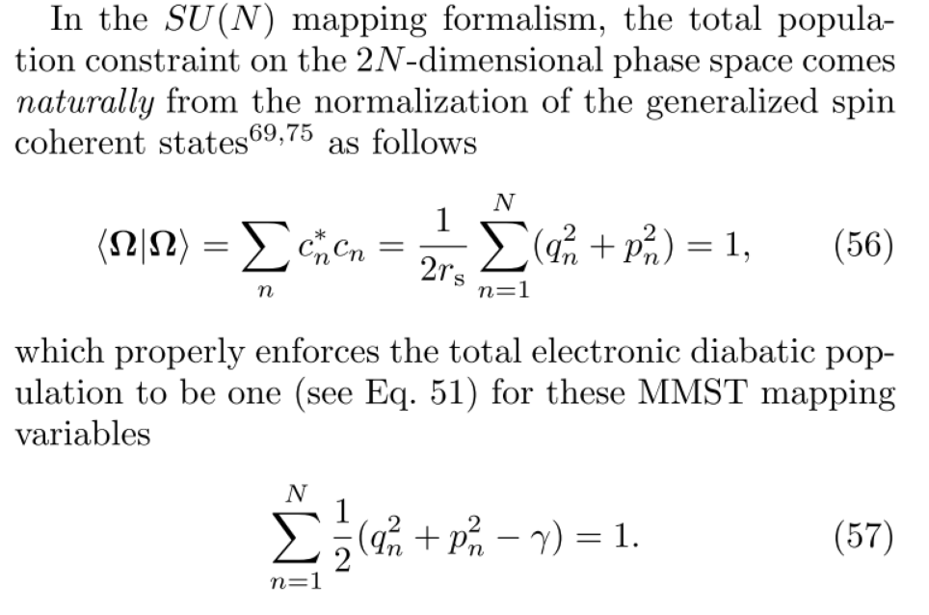

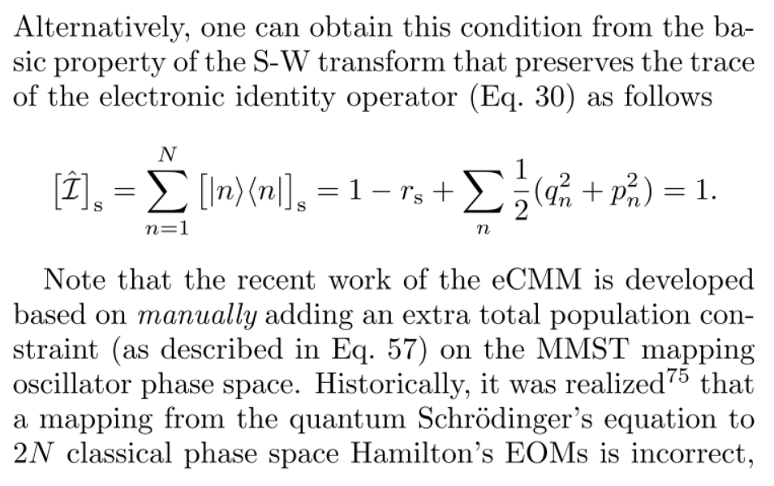

”

and the left part of page 24 of Version 3 (first online on July 29, 2022)

“

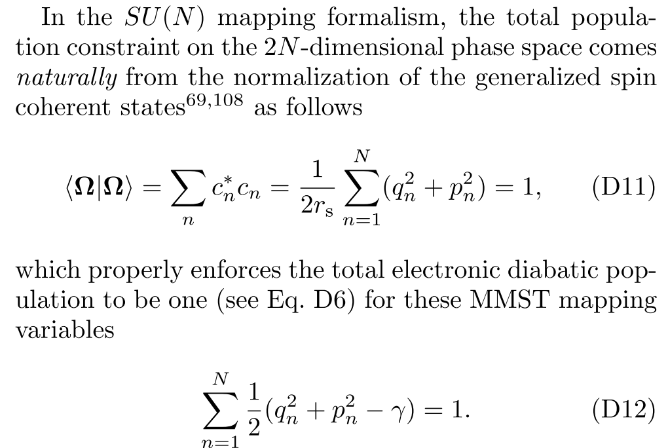

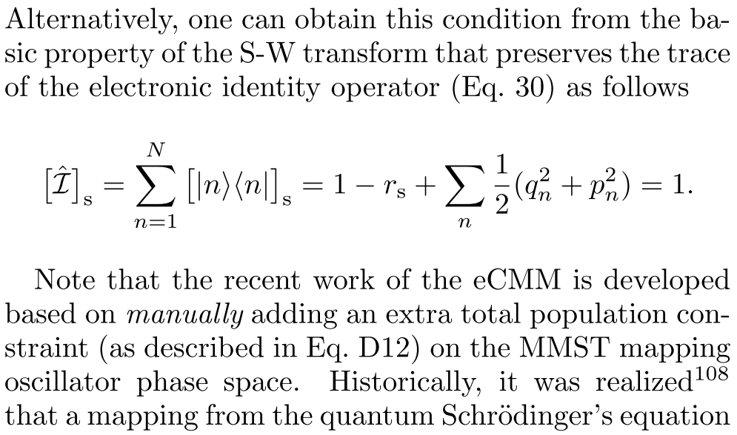

”

They mentioned the constraint requiring that the sum over electronic population is equal to 1, but neglected the fact that this normalization/constraint had been first proposed in eq (28) of *J. Chem. Phys.* 151, 024105 (2019) (Submitted on May 1, 2019, accepted on June 11, 2019 and published on July 9, 2019):

“

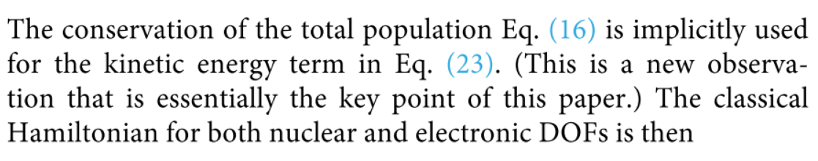

”

“

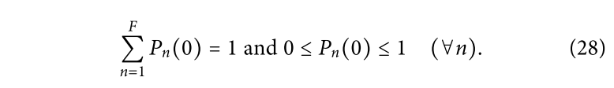

”

In the paper *J. Chem. Phys.* 151, 024105 (2019), we first presented the idea of constraint manifold, which can be actually parameterized by whether Meyer-Miller variables or Stratonovich angles variables. Using this constraint, the Q, W, or P versions of spin mapping methods (in Stratonovich phase space) proposed in J. Chem. Phys. 152, 084110 (2020) are only three special cases of classical mapping model(CMM) methods (in Mayer-Miller variables in constraint coordinatge-momentum phase space). Later, the relationship is further clarified again in our paper *Wiley Interdiscip. Rev. Comput. Mol. Sci.* e1619 (2022) (submitted on February 5, 2022, released on arXiv on May 8, 2022 and officially published on May 13, 2022). Neither Version 1 nor Version 2 cited this article!

And in our *J. Phys. Chem. Lett.* 12, 2496–2501 (2021) (submitted on January 22, 2021, accepted on February 19, 2021 and published online on March 5, 2021), we had clearly clarified the one-to-one mapping (i.e., mapping and inversed mapping) between identity operator and 1:

“

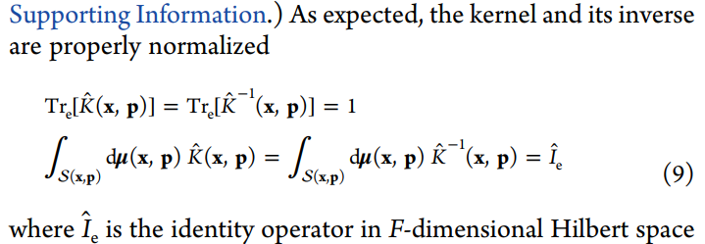

”

Huo and his coworkers interpreted *our* ideas in **their** own way and claimed such ideas to be **theirs.**

**Evidence #3:**  Huo and his coworkers changed the title from

“Non-adiabatic Dynamics using the Generators of the  Lie Algebra” (Version 1, online on May 20, 2022)

to

“Non-adiabatic Mapping Dynamics in the Phase Space of the SU(N) Lie Group” (Version 2, online on May 27, 2022; and Version 3, online on July 29, 2022)

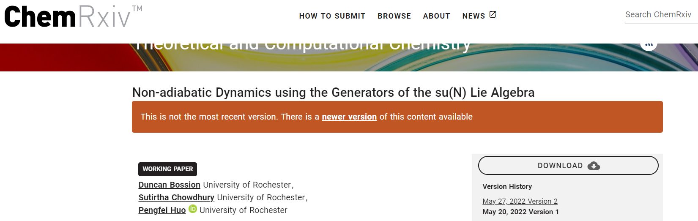

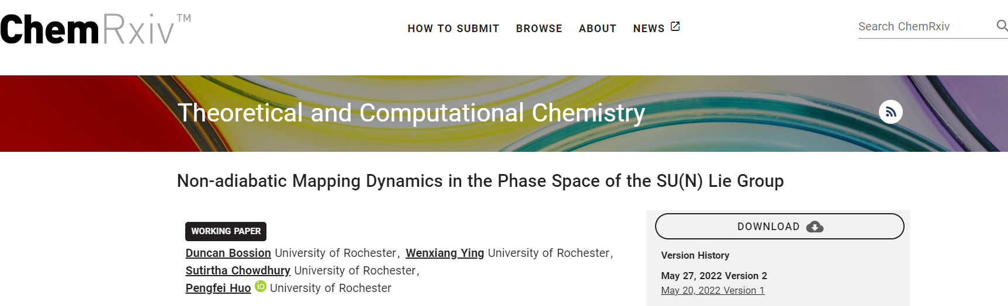

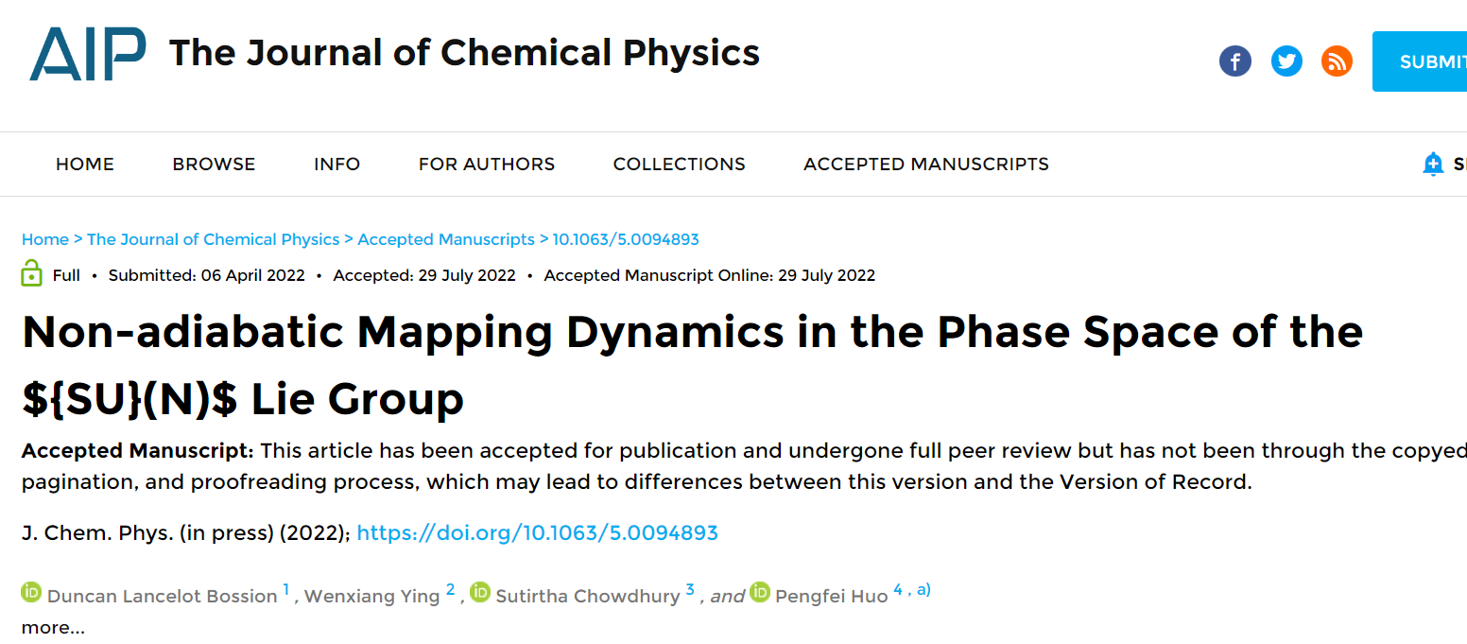

For comparison, the title of our WCMS paper was

“New phase space formulations and quantum dynamics approaches” (submitted on February 5, 2022, released on arXiv on May 8, 2022 and officially published on May 13, 2022).

One main theme of the paper had been focused on mapping dynamics for nonadiabatic systems, where the Stratonovich phase space with an SU(2) or SU(F) structure had been discussed.

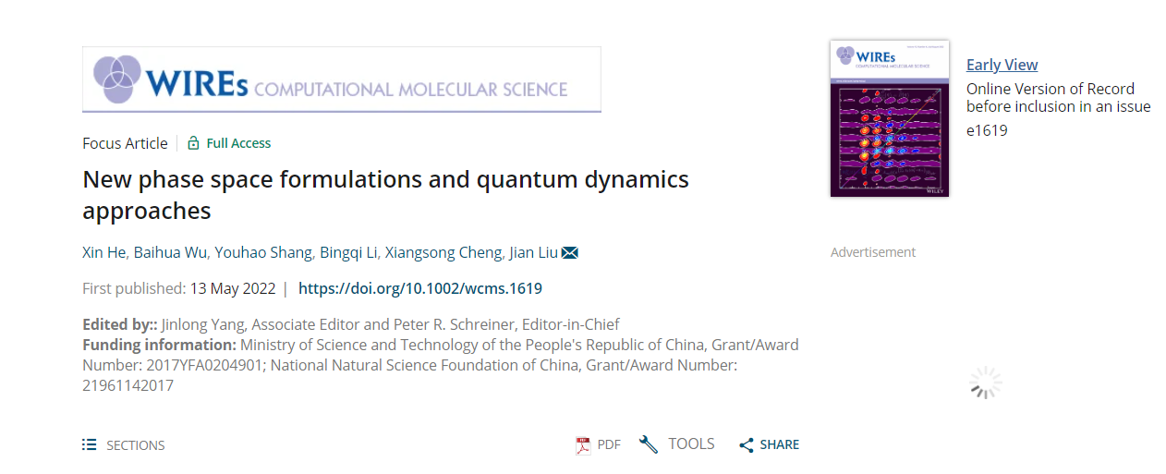

**Evidence #4:** Huo and his coworkers directly copied our understanding on describing groups and phase spaces as smooth and differential manifolds.

The term, “smooth manifold”, appeared firstly in our paper *Wiley Interdiscip. Rev. Comput. Mol. Sci.* e1619 (2022)(submitted on February 5, 2022, released on arXiv on May 8, 2022 and officially published on May 13, 2022), for describing phase spaces (including  or  *groups*):

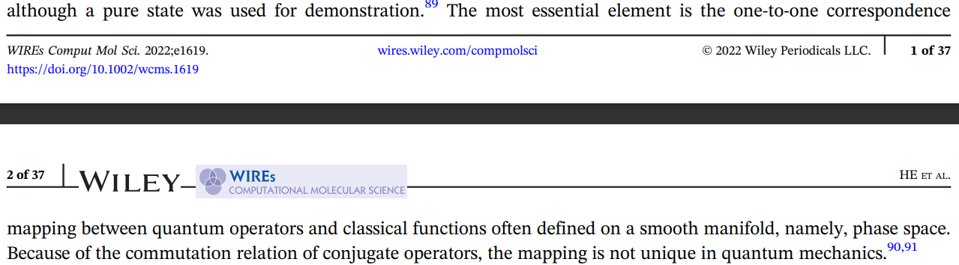

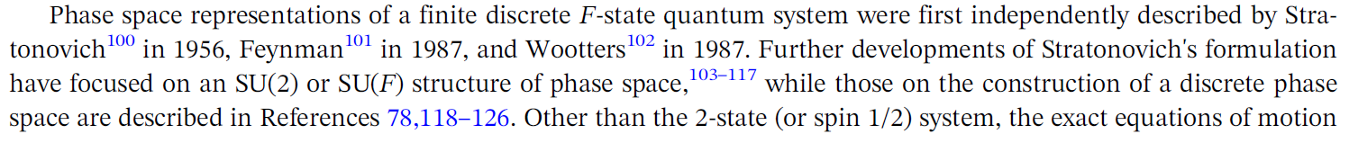

and in our *Wiley Interdiscip. Rev. Comput. Mol. Sci.* e1619 (2022) the term “diffeomorphic” was used for describing differential manifolds (phase spaces) in Appendix 3:

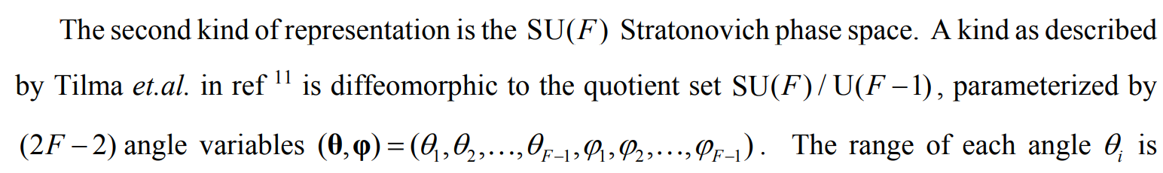

Yet, neither “differential manifold” nor “smooth manifold” existed in Version 1 of Huo and his coworkers, and groups were not described as manifolds. In Version 2 of Huo and his coworkers, “differential manifold” and “Lie group/manifold” started to appear, and Huo and his coworkers started to describe groups as manifolds; and in Version 3 of Huo and his coworkers, the term “smooth manifold” were copied from ours. In not any of these cases were our works cited.

An incomplete list of these kinds of plagiarism is shown below.

|  |  |
| --- | --- |
| **Version 1 (first online on May 20, 2022)** | **Version 2 (first online on May 27, 2022)** |
| **(abstract)** | **(abstract)** |
| **(page 2)** | **(page 2)** |
| **(page 4)** | **(page 5)** |
| **(page 5)** | **(page 6)** |
| **No corresponding part** | **(page 2)** |

|  |  |
| --- | --- |
| **Version 1 (first online on May 20, 2022)** | **Version 3 (first online on July 29, 2022)** |
| **(abstract)** | **(abstract)** |
| **(page 2)** | **(page 2)** |
| **(page 4)** | **(page 5)** |
| **(page 5)** | **(page 6-7)** |
| **No corresponding part** | **(page 2)** |

**Evidence #5:**

In Version 1 of Huo and his coworkers’ manuscript (first online on May 20, 2022), the authors failed to discern  Lie algebra from  Lie groups, confounding them everywhere in the manuscript. They even *created* the ridiculous term “ group” in the introduction section, which could hardly be written by any scholars who know Lie group or Lie algebra. Also, Huo and his coworkers did not realize that the key of phase space mapping should be the Lie group structure rather than Lie algebra. These problems kept existing even after we had released our *Wiley Interdiscip. Rev. Comput. Mol. Sci.* e1619 (2022) on Arxiv on May 8, 2022, with correct  groups mentioned. In later versions (Version 2 online on May 27, 2022 and Version 3 online on July 29, 2022), Huo and his coworkers directly *poached* our statements/ideas, correcting these mistakes under our influence without mentioning our works. In Version 2-3, there are *more than 30* statements where the issues stated here involved, as this incomplete list shows.

|  |  |
| --- | --- |
| **Version 1 (first online on May 20, 2022)** | **Version 2 (first online on May 27, 2022)** |
| **(page 1)** | **(page 2)** |
| **(pages 2-3)** | **(page 3)** |
| **pages 3** | **(page 4)** |
| **(page 7)** | **(page 8)** |
| **(page 7)** | **(page 9)** |
| **(page 9)** | **(page 10)** |
| **(page 16)** | **(page 19)** |
| **(page 18)** | **(page 19)** |
| **(page 20)** | **(page 22)** |
| **(page 20)** | **(page 23)** |
| **(page 21)** | **(page 23)** |
| **No corresponding part** | **(page 24)** |
| **(page 8)** | **(page 31)** |
| **(page 16)** | **(page 32)** |
| **(Page 2)** | **(page 2)** |
| **(page 8)** | **(page 9)** |
| **No corresponding part** | **(page 24)** |

|  |  |
| --- | --- |
| **Version 1 (first online on May 20, 2022)** | **Version 3 (first online on July 29, 2022)** |
| **(page 1)** | **(page 2)** |
| **(pages 2-3)** | **(page 3)** |
| **(page 3)** | **(page 4)** |
| **(page 7)** | **(page 23)** |
| **(page 7)** | **(page 24)** |
| **(page 9)** | **(page 9)** |
| **(page 16)** | **(page 16)** |
| **(page 18)** | **(page 16)** |
| **(page 20)** | **(page 19)** |
| **(page 20)** | **(page 19)** |
| **(page 8)** | **(page 25)** |
| **(page 2)** | **(pages 2-3)** |
| **No corresponding part** | **(page 5)** |
| **(page 8)** | **(page 24)** |

**Evidence #6:** In Version 1 (first online on May 20, 2022), the equations of motion eqs (98), (101) and (105), **with the coherent states eq (17),** were actually **wrong**. The authors even **emphasized** the various pros of their new spin coherent states. It means that the inconsistence was not because of typos, but serious mistakes.

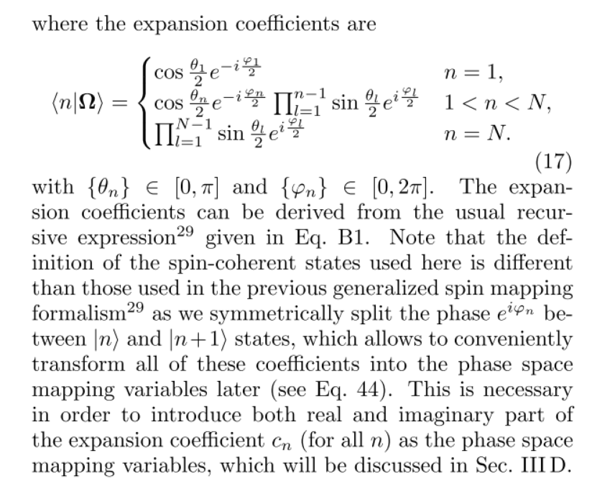

The equations of motion were **incorrect** for systems with 3 or more electronic states, however *happened to be correct* only for two-electronic-state systems. (See Numerical tests in ***)

Though they added a note, Ref. 56 in their Version 2 (first online on May 27, 2022), stating that their mistakes did not affect physical expectations, it *truly* affects dynamics and can make severe problems in numerical tests(See Numerical tests in ***). It is then very suspicious that the results obtained by the authors for the three-state system in Figures 4 and 5 of Version 1, did not faithfully employ their **wrong** equations of motion. We must seriously query that whether the data were made-up? The authors should provide the original source code for Figure 4 and 5 of Version 1 to do the investigation.

In our paper *Wiley Interdiscip. Rev. Comput. Mol. Sci.* e1619 (2022) (submitted on February 5, 2022, released on arXiv on May 8, 2022 and officially published on May 13, 2022), we had already published the correct EOMs on Stratonovich phase space before the online time of Huo *et al.*’s two Versions. It is evident that Huo and his coworkers carefully studied our arXiv preprint paper before May 27, 2022 (see Evidence #9).

Nearly three weeks existed between May 8, 2022 and May 27, 2022, which should have been enough for Huo and his coworkers to plagiarize the ideas of the correct EOMs in the *Wiley Interdiscip. Rev. Comput. Mol. Sci.* e1619 (2022) preprint/paper, and then realized their EOMs were wrong. The plagiarism did take Huo and his coworkers quite some time. Although Wenxiang Ying and the Huo group claimed on May 14, 2022 (Rochester Time) that they had already been studying the arXiv preprint of *Wiley Interdiscip. Rev. Comput. Mol. Sci.* e1619 (2022), they still failed to understand that their EOMs of Version 1 were wrong until at least May 20, 2022, when Version 1 was released on ChemRxiv. Not until May 27, 2022 did Huo and his coworkers released their Version 2 that finally included the correct EOMs.

|  |  |
| --- | --- |
| **Version 1 (first online on May 20, 2022)** | **Version 2 (first online on May 27, 2022)** |
|  |  |
|  |  |
| No corresponding part |  |

|  |  |
| --- | --- |
| **Version 1 (first online on May 20, 2022)** | **Version 3 (first online on July 29, 2022)** |
|  |  |
|  |  |

Even if in numerical level, authenticity of data in authors’ paper should be questioned. Authors declaimed that *they used EOMs of Stratonovich phase space* (see eq (115)) to obtain results in Version 1 (online on May 20, 2022), while in Version 2 (online on May 27, 2022) and Version 3 (accepted on July 29, 2022), they changed their statements that *they used EOMs of action-angle variables* to obtain the same results (see eq (128) in Version 2 and eq (106) in Version 3). Due to the nature of Monte Carlo algorithm, these results **CANNOT** be exactly the same with Version 1, especially regarding that Huo and his coworkers claimed that the corresponding algorithms were **different**! However, figures in three Versions were **HIGHLY SIMILAR**, indicating high possibility of **DATA FRAUD**. The corresponding codes used to generate these figures must be provided by Huo and his coworkers.

The figures:

|  |  |
| --- | --- |
| **From Version 1 (online on May 20, 2022), Fig. 3**  **(similarities circled by violet line)** | **From Version 2 (online on July 29, 2022), Fig. 3**  **(similarities circled by violet line)** |
|  |  |

|  |  |
| --- | --- |
| **Version 1 (online on May 20, 2022), Fig. 3**  **(similarities circled by violet line)** | **Version 3 (online on July 29, 2022), Fig. 3**  **(similarities circled by violet line)** |
|  |  |

Huo and his coworkers had indicated in Version 1 and 2 that they used the EOMs on the Stratonovich phase space in numerical simulations:

|  |  |
| --- | --- |
| **From Version 1 (online on May 20, 2022)** | **From Version 2 (online on July 29, 2022)** |
|  |  |

|  |  |
| --- | --- |
| **Version 1 (online on May 20, 2022)** | **Version 3 (online on July 29, 2022)** |
|  |  |

The methods used to generate the figures, as Huo and his coworkers stated:

|  |  |
| --- | --- |
| **From Version 1 (online on May 20, 2022)** | **From Version 2 (online on July 29, 2022)** |
|  |  |

|  |  |
| --- | --- |
| **Version 1 (online on May 20, 2022)** | **Version 3 (online on July 29, 2022)** |
|  |  |

**Evidence #7:** The global phase introduced around eq (46) of Version 2 (first online on May 27, 2022) was totally a plagiarism from eq S54 in *Wiley Interdiscip. Rev. Comput. Mol. Sci*. e1619 (2022) (submitted on February 5, 2022, released on arXiv on May 8, 2022 and officially published on May 13, 2022). The global phase, linking the constraint coordinate-momentum phase space in Meyer-Miller variables and the Stratonovich phase space, had been first discussed in Appendix 3 of *Wiley Interdiscip. Rev. Comput. Mol. Sci.* e1619 (2022). In the second paragraph of page 8 of Huo’s Version 1(online on May 20, 2022), they only mentioned the global phase in short, simply thinking that it would not affect *quantum dynamics*.

“

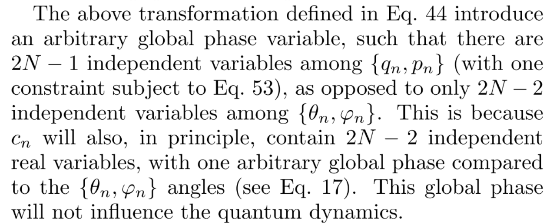

”

However, the global phase abruptly involved in some key equations of Version 2-3 while completely absent in previous Version 1:

|  |  |
| --- | --- |
| **Version 1 (online on May 20, 2022)** | **Version 2 (online on May 27, 2022)** |
|  |  |
|  |  |

|  |  |
| --- | --- |
| **Version 1 (online on May 20, 2022)** | **Version 3 (online on July 29, 2022)** |
|  |  |
|  |  |

Actually, the global phase abruptly added here had been introduced in the eq (S54) of *Wiley Interdiscip. Rev. Comput. Mol. Sci.* e1619 (2022) (submitted on February 5, 2022, revised on April 8, 2022, released on arXiv on May 8, 2022 and officially published on May 13, 2022):

“

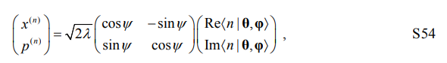

”

Huo *et al.* obviously plagiarized the global phase into their representation from *Wiley Interdiscip. Rev. Comput. Mol. Sci*. e1619 (2022). Moreover, a constant global phase still does not lead to the correct form of canonical Hamilton's equations of motion with Meyer-Miller variables (See numerical test in XXX).

**Evidence #8**:

There are several literatures that were only cited in the Version 2 (online on May 27, 2022), and Version 3(online on July 29, 2022) but **not in their** **Version 1** (first online on May 20, 2022)**.** Especially, one reference, Ref. 37[M. A. Marchiolli and D. Galetti, *J. Phys. A: Math. Theor.* 52, 405305 (2019)], had been cited in *Wiley Interdiscip. Rev. Comput. Mol. Sci.* e1619 (2022), whose arXiv version was released on May 8, 2022, and whose official version was published on May 13, 2022 before their updated **Version 2** on May 27, 2022. The authors obviously saw this important citation from our *Wiley Interdiscip. Rev. Comput. Mol. Sci.* e1619 (2022) and used it in Version 2 and Version 3.

“

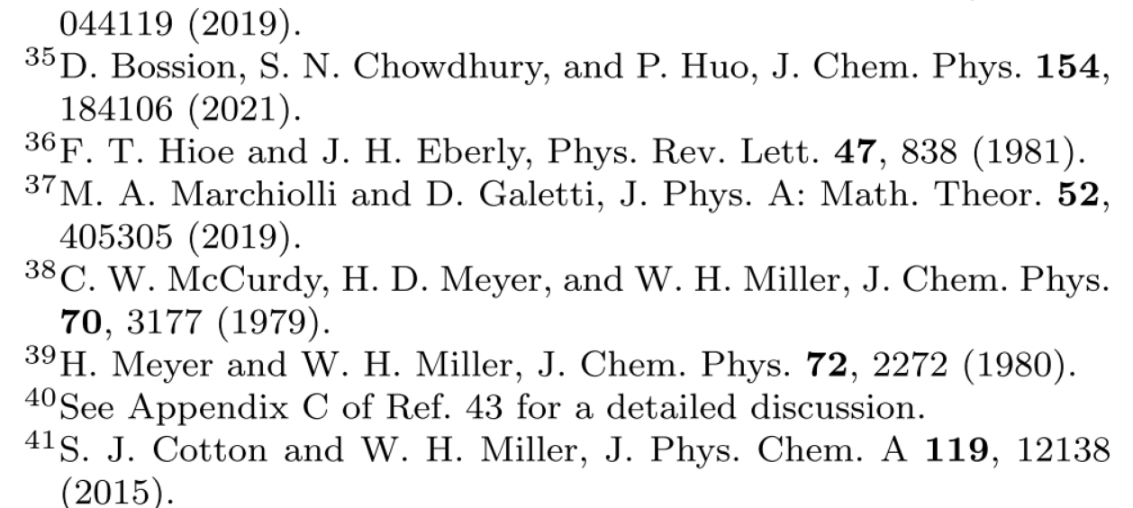

”

Version 3:

“

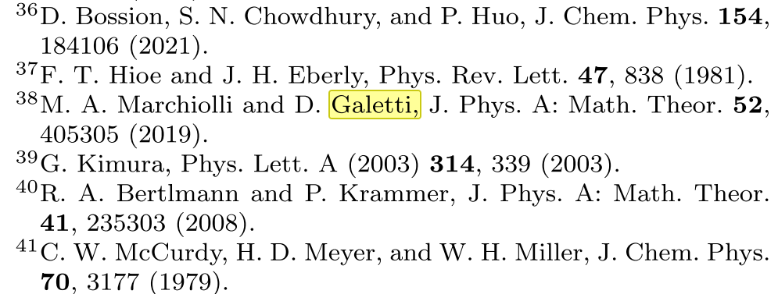

”

*Wiley Interdiscip. Rev. Comput. Mol. Sci*. e1619 (2022):

“

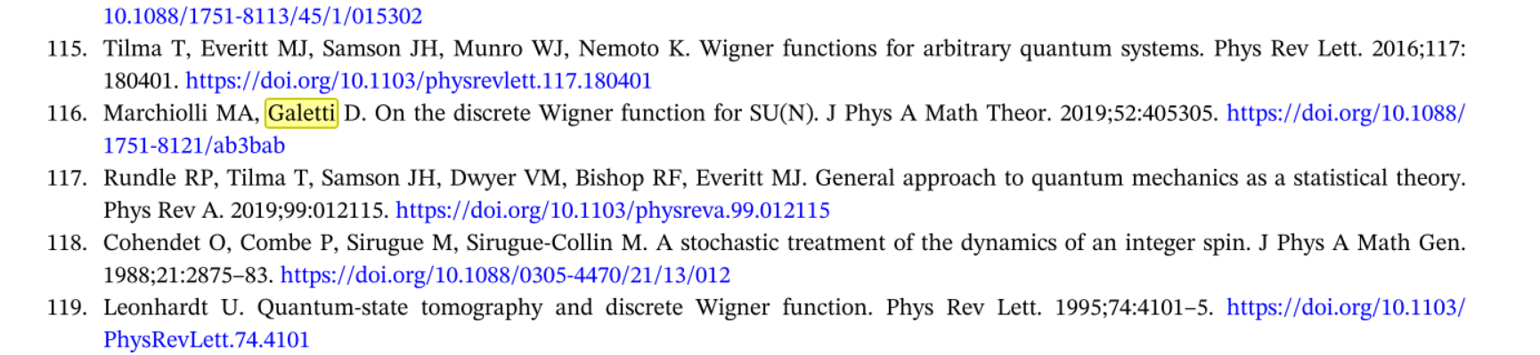

”

In addition, Ref. 28[A. B. Klimov and S. M. Chumakov, A Group-Theoretical Approach to Quantum Optics: Models of Atom-Field Interactions (John Wiley & Sons, 2009).] of Version 2-3 was not cited in Version 1:

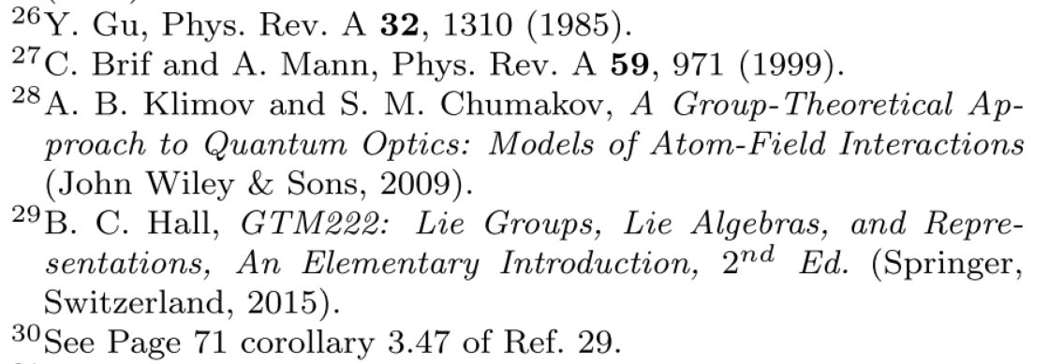

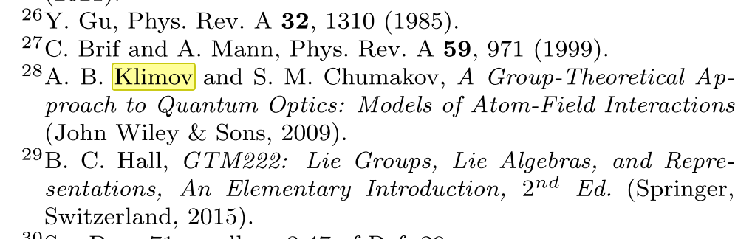

while at least 7 articles by Klimov and his coworkers were cited by *Wiley Interdiscip. Rev. Comput. Mol. Sci.* e1619 (2022) (released on arXiv on May 8, 2022 and officially published on May 13, 2022), in comparison, none of Klimov’s work had been cited by Huo and coworkers in Version 1:





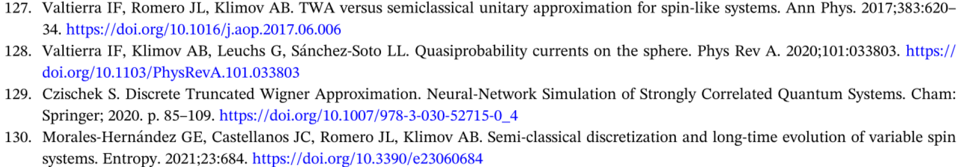





**Evidence #9:** Wenxiang Ying, the second author of Version 2, hinted that they were aware of the arXiv Version(<https://arxiv.org/abs/2205.03870>, released on May 8, 2022) of Wiley Interdiscip. Rev. Comput. Mol. Sci. e1619 (2022) on May 14, 2022 (Rochester Time) on Zhihu website (<https://www.zhihu.com/people/liu-xing-yu-72-53/pins>, in Chinese) and spread rumors to discredit the reputation of the possible reviewers, before they released either Version 1(May 20, 2022, <https://chemrxiv.org/engage/chemrxiv/article-details/6286c9ba59f0d6831996a480> ) or Version 2(May 27, 2022, <https://chemrxiv.org/engage/chemrxiv/article-details/6290092c1df2edd1ac59ea52> ) on ChemRxiv.



Translation: Released on 08:29, May 15, 2022 (Beijing Time, which is 20:29, May 14, 2022, Rochester Time)

Translation: Until a few days later, the reviewer group posted an article with very similar content on arXiv…

Translation: We received the reply (from the editor) on May 5 and they submitted the article on May 8.



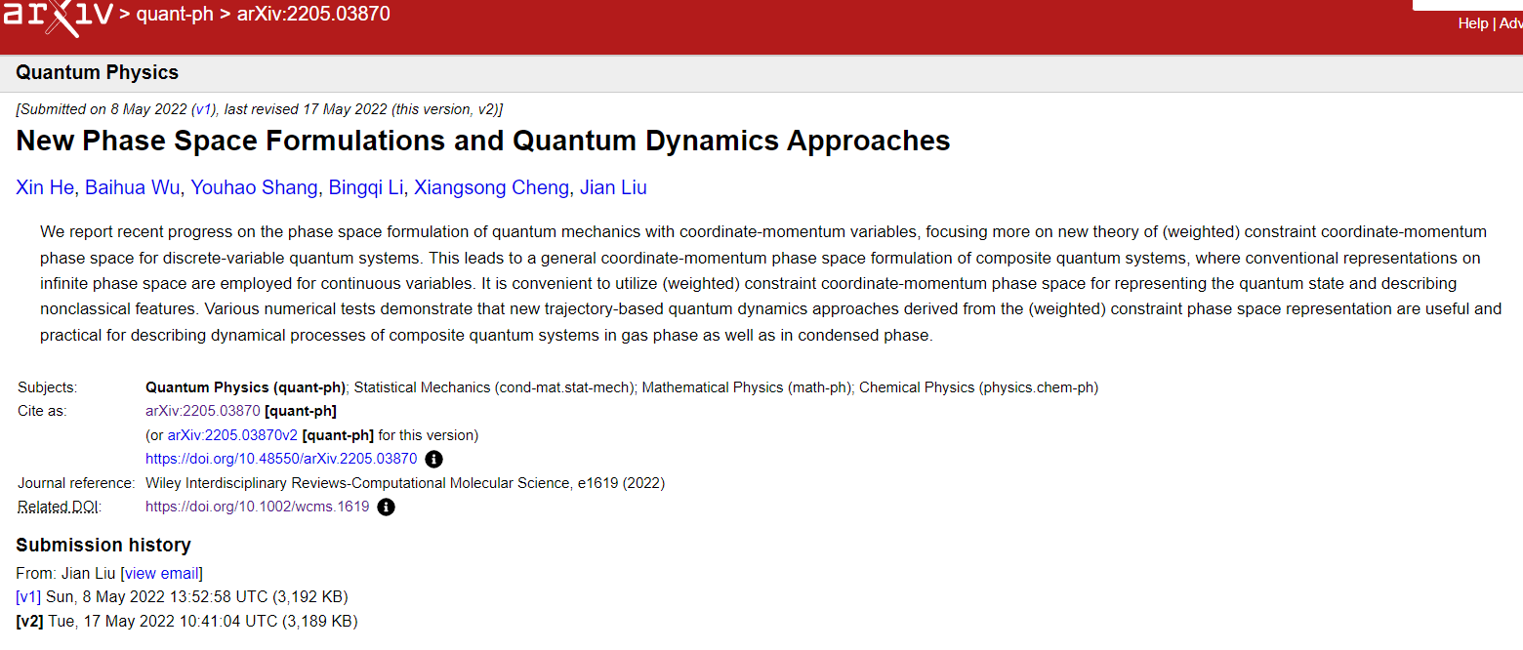





**Evidence #10:** In Version 1, there existed at least 8 parts that the authors directly plagiarized from J. Chem. Phys. 152, 084110 (2020) by Richardson and coworkers without any citations. We list these comparisons below:

|  |  |
| --- | --- |
| **Version 1 (online on May 20, 2022)** | ***J. Chem. Phys.* 152, 084110 (2020)** |
|  |  |
|  |  |
|  |  |
|  |  |
|  |  |
|  |  |
|  |  |
|  |  |

In Version 2-3, these issues still exist:

|  |  |
| --- | --- |
| **Version 2 (online on May 27, 2022)** | ***J. Chem. Phys.* 152, 084110 (2020)** |
|  |  |
|  |  |
|  |  |
|  |  |
|  |  |
|  |  |
|  |  |
|  |  |

|  |  |
| --- | --- |
| **Version 3 (online on July 29, 2022)** | ***J. Chem. Phys.* 152, 084110 (2020)** |
|  |  |
|  |  |
|  |  |
|  |  |
|  |  |
|  |  |
|  |  |
|  |  |

**Evidence #11:** Note 64 of the reference list in Version 2 (online on May 27, 2022) or Note 65 in Version 3 (online on July 29, 2022) did not appear in Version 1 (online on May 20, 2022), which implies the modified parts from Version 1 to Version 2-3 were influenced by *Wiley Interdiscip. Rev. Comput. Mol. Sci.* e1619 (2022) (submitted on February 5, 2022, revised on April 8, 2022, released on arXiv on May 8, 2022 and officially published on May 13, 2022).

Huo and his coworkers added the note to illustrate that they were never aware of the kernel form of eq (27) of Version 2 or Version 3 in pervious articles, while they did not mention this point in Version 1.

|  |  |
| --- | --- |
| **Version 1 (online on May 20, 2022)** | **Version 2 (online on May 27, 2022)** |
|  |  |
| No corresponding part |  |

|  |  |
| --- | --- |
| **Version 1 (online on May 20, 2022)** | **Version 3 (online on July 29, 2022)** |
|  |  |
| No corresponding part |  |

However, the kernel formalism of eq (27) had already been proposed in J. Phys. A: Math. Theor. 45, 015302 (2012) as stated in Appendix 3 of Wiley Interdiscip. Rev. Comput. Mol. Sci. e1619 (2022):

|  |  |
| --- | --- |
| **Version 2 (online on May 27, 2022)** | **Wiley Interdiscip. Rev. Comput. Mol. Sci. e1619 (2022)**  **(submitted on February 5, 2022, released on arXiv on May 8, 2022 and officially published on May 13, 2022)** |
|  |  |

Ref. 11 [*J. Phys. A: Math. Theor.* 45, 015302 (2012)] cited in Appendix 3 of Wiley Interdiscip. Rev. Comput. Mol. Sci. e1619 (2022) had also clearly presented a kernel formalism,

“



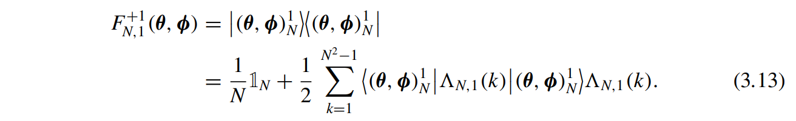

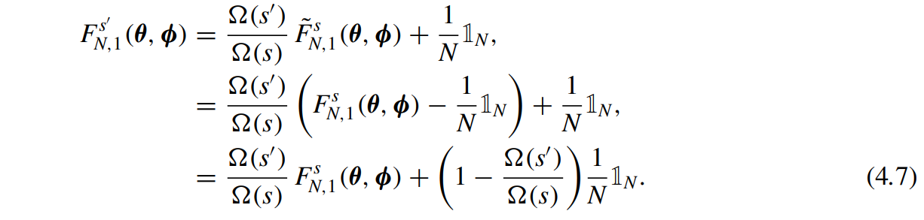

”

So how could they say that “to the best of our knowledge, we do not see this expression in the previous literature” while they cited our work nowhere, but still cited *J. Phys. A: Math. Theor.* 45, 015302 (2012) in all of Version 1 (see Ref. 43), Version 2 (see Ref. 50) and Version 3 (see Ref. 53)? (They even made a mistake on the year of this reference)

This evidence indicates that they had studied our work *Wiley Interdiscip. Rev. Comput. Mol. Sci.* e1619 (2022) before they released their Version 2 (online on May 27, 2022) and Version 3 (online on July 29, 2022), and pretended others’ scientific contributions as their first ideas. Huo and his coworkers should explain why they added this note in Version 2.